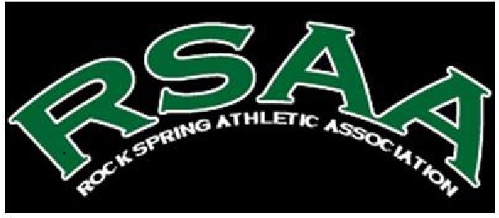
BUILDING COMMUNITY WITH YOU

Dear Community-Minded Business Manager,
For many years, Rock Spring Athletic Association has delivered the finest choices in community recreation to residents and guests. Last year over 200 girls and boys ages 4-12 participated in organized team sports.
Rock Spring Athletic Association is popular for reasons such as better health, community connections and of course, fun. Studies show that participating in local recreation programs, parks and facilities have other important benefits that contribute greatly to the success of a community; economic development, public safety and increased property values to name a few.
We are proud to share with you our ballpark league offerings and ask you to consider supporting Rock Spring Athletic Association through sponsorship, advertising or in-kind contributions.
We have included some program sponsorship opportunities for your review. Please keep in mind that some programs are seasonal and have publicity deadlines. If you have an interest in discussing any of the opportunities that are available, please contact Josh Myers at rsaasports1@gmail.com or 423-653-1642.
Your support will help fuel an active community and enrich the lives of young and old alike.
Thank you for your consideration!
Josh Myers
Baseball/Softball Commissioner
COMPANY NAME ______________________________________________________________________
ADDRESS _____________________________________________________________________________
CITY ______________________ STATE____________, ZIP___________ PHONE (____)_____-________
SPONSORSHIP | AGE F/M | PRICE | QTY | TOTAL COST | TEAM NAME SPONSORED
T-BALL TEAM | 3-4 F/M |  | N/A
BASEBALL TEAM | 5-12 M |  | N/A
SOFTBALLTEAM | 5-12 F |  | N/A
SOCCER TEAM | 5-14 M/F |  | N/A
FOOTBALL TEAM | 5-12 M |  | N/A
CHEER SQUAD | 5-12 F |  | N/A
*BALL FIELD SIGN | $85 for sign $100 to team $100 to rec | $285

* EMAIL rsaasports1@gmail.com your logo as a pdf. SUBJECT: BALLFIELD SIGN FOR (COMPANY NAME)

